C390 - Portfolio Development Module

|  |  |
| --- | --- |
| **Summary** | C390 Administrative Instruction for Portfolio Development Module |
| **URL** | c390 |
| **Category** | Web |
| **Environment** | web, kiosk, io2016, pwa-dev-summit, pwa-roadshow, chrome-dev-summit-2016, io2017, typtwd17, gdd17, cds17, io2018, tag-web, jsconfeu, devfest18, io2019 |
| **Status** | Published |
| **Feedback Link** | https://github.com/googlecodelabs/your-first-pwapp/issues |
| **Author** | TAN KOK CHENG |
| **Author LDAP** | TAN KOK CHENG |
| **Analytics Account** | UA-152045256-1 |

# Overview of C390

C390 Portfolio Development module helps to apply what you have learnt in Diploma in Mobile Software Development to create a showcase of the web and mobile apps that you had created.

This is a 2-semester module and you will be taking it in year 2 semester 2 and year 3 semester 1. Each student will be assigned a supervisor to guide and mentor them in the development of their portfolio. Each student must put up **at least 4 projects** for the module. You are expected to complete at least 3 projects in year 2 semester 2 so that you can better focus in your Final Year Project in year 3 semester 1.

Specifically,

1. Create a blog site for portfolio
2. On your own blog site, create a blog post for every project. You must have one blog post for each project. Each post should be updated with a proposal, storyboard and competitive analysis of the project.  
   Take a look at your seniors’ work at [Exemplary Portfolios](https://kokcheng.github.io/c390/index.html#3). These portfolios serve as a guide and but you are encouraged to surpass them.
3. Competitive Analysis should have the following
   * 2 competitors at least
   * Competitors product name and URL to their apps/website
   * Competitors’ features and gaps
   * SWOT

You will be graded on both the process and the final deliverable of the projects. The process and deliverable are graded based on the 4 components with their weight as shown below.

|  |
| --- |
| * Technical – 30% * Concept and Approach – 30% * Creativity and Uniqueness – 30% * Presentation – 10% |

Source of projects:

* [Daily Problem](https://kokcheng.github.io/c390/index.html#4)
* FYP Related
* Creativity
* Hackathon
* Competition
* [Baseline Proposals](https://kokcheng.github.io/c390/index.html#5)

You should have a clear idea of the different milestones so that you do not fall behind schedule. There will be supplementary talks to help to equip you with building your portfolio. The schedule for the talks can be accessed [here](https://kokcheng.github.io/c390/index.html#2). You can access the materials used in briefing and talks [here](http://pd.trytocode.com/talksbriefing-materials/).

We have two labs that you can use to work on your portfolio. They are Samsung Lab at E63A (available every school day) and iOS Lab at E63B (available on day 3 and day 4). Please approach your supervisor on arrangement to access the labs.

# Talk/ Briefing material

[Slides](https://drive.google.com/open?id=1vvfdxCBBB9Y_z0jFBe6nXj5G5fLcGRrG)

|  |  |  |
| --- | --- | --- |
| Date | Talk | Speaker |
| Week 2 | 1st PD BriefingPortfolio Content and Delivery  Sharing on Building Portfolio | Mr Tan Kok Cheng |
| Week 4 | Storyboard and Flowchart | Mr Ryan Low |
| Week 5 | Adding chatbot to your project | Mr Hew Ka Kian |
| Week 6 | Design and Icons | Ms Julia Lee |
| Week 8 | Distributing via Amazon Appstore  Guide to Using Free Web and Data Hosting 000webhost.com | Ms Denise Quek |

# Schedule and Timeline

|  |  |
| --- | --- |
| **Task** | **Date** |
| Start 1st App | 23 Oct 2019 (AY2019, Semester 2 Week 2) |
| Complete 1st App | 22 Nov 2019 (AY2019, Semester 2 Week 6) |
| Start 2nd App | 22 Nov 2019 (AY2019, Semester 2 Week 6) |
| Complete 2nd App | 10 Jan 2020 (AY2019, Semester 2 Week 9) |
| Start 3rd App | 10 Jan 2020 (AY2019, Semester 2 Week 9) |
| Complete 3rd App | 14 Feb 2020 (AY2019, Semester 2 Week 13) |
| Start 4th App | 1 Mar 2020 (Semester Break) |
| Portfolio submission to LEO  (First 3 apps plus blog) | 4 May 2020 (AY2020, Semester 1 Week 2) |
| Mid Grading by supervisor (20%) | 11 May 2020 (AY2020, Semester 1 Week 3) |
| Complete 4th App | **28 May 2020 (AY2020, Semester 1 Week 6)** |
| Portfolio submission to LEO  (all 4 apps plus blog) | **3 Jun 2020 (AY2020, Semester 1 Week 7)** |
| Final Assessment by assessors (50%) | **11 Jun 2020**  **15 Jun 2020** |
| Final Grading by supervisor (30%) | **Make arrangement with your supervisor** |

# Sample Blog site by Past DMSD students

These are some examples of well written blogs that have been done by your seniors. You may use them as a reference in the design of your own blog.

|  |  |
| --- | --- |
| **Name** | **Blog Link** |
| Glenn | <https://moeadminblog.wordpress.com/> |
| Suhaili | <https://suhailicodehut.wordpress.com/> |
| Hong Liang | <https://hongliangatm.wordpress.com/> |
| Elisha | <https://elishazacarias.wordpress.com/> |
| Anjana | <https://worldofcodeanjana.wordpress.com/> |
| Qairul | [https://qaitessential.wixsite.com/officialqairul](https://qaitessential.wixsite.com/officialqairul/) |

# Ideas from Class Problems

You may use what you have done in class as the baseline to continue to enhance and further develop your apps. However, check with your supervisor to make sure that the additional scope of work is large enough to justify the time and effort that you are required to put in for the PD module.

|  |  |
| --- | --- |
| **Module** | **Problem** |
| C273 | P06 Creating your mobile website using Bootstrap UI and Validator  P12 Enhancing your app using HTML5 local storage or DnD API  P13 Creating location based mobile web apps |
| C348 | P03 BMI Calculator (no enhancement, no design given)  P05 Memory Game (Match face and name, no enhancement, no design given)  P13 Self suggested app based on a theme (TBD) |
| C346 | P07 What Should I Do? (To-Do List App)  P10 Reservation Enhanced |
|  | |

# Sample Proposals

If you have difficulty coming up with your own idea for the app, you may refer to the sample proposal given below, and use them as a template to develop your app. Take note that you should include additional features, and add in some of your own ideas if you decide to use any of the sample proposal.

[Links to Proposals](https://drive.google.com/open?id=1mwCcJ-geoaFR7syXXfRiQ-Tz5PaN9LZ0)

|  |  |  |
| --- | --- | --- |
| **No** | **Proposal Title** | **Lecturer Proposed** |
| 1 | Animal Hunt App | Leonard Gan |
| 2 | Biking Trail App | Charissa Chua |
| 3 | Currency Exchange | Hew Ka Kian |
| 4 | Game | Ryan |
| 5 | Movies Groupies App | Lydia |
| 6 | My Saving Calculator | Nam Huat |
| 7 | Push Up Tracking App | Kok Cheng |
| 8 | Quiz Correction App | Charissa Chua |
| 9 | Quotes | Ka Kian |
| 10 | Receipt Keeping App | Andy Tao |
| 11 | Simple Earthquake Alarm App | Andy Tao |
| 12 | Tourist Attractions App | Dilrukshi |
| 13 | Treasure Hunt | Leonard |
| 14 | Who Pay the Bill | Nam Huat |
| 15 | Habit Tracker | Denise Quek |
| 16 | Travel Planner App | Denise Quek |

# Sample Storyboards from C294 Year 1 Students

The following are examples of well-designed storyboards from the Year 1 students.

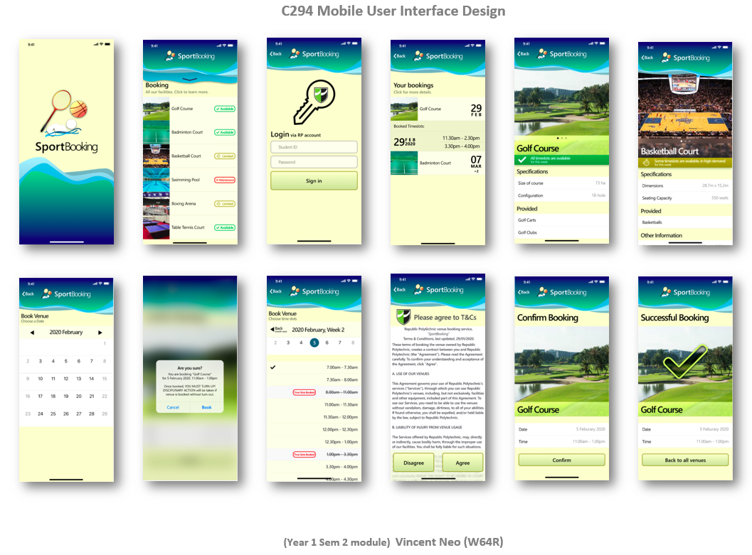

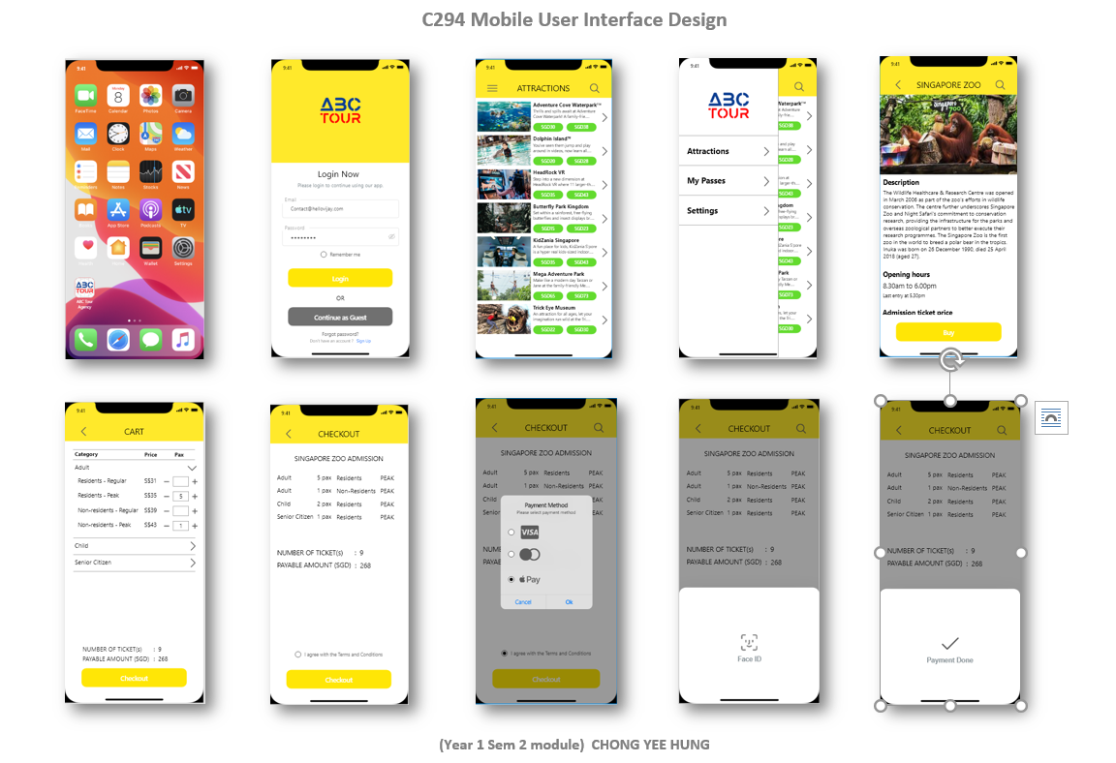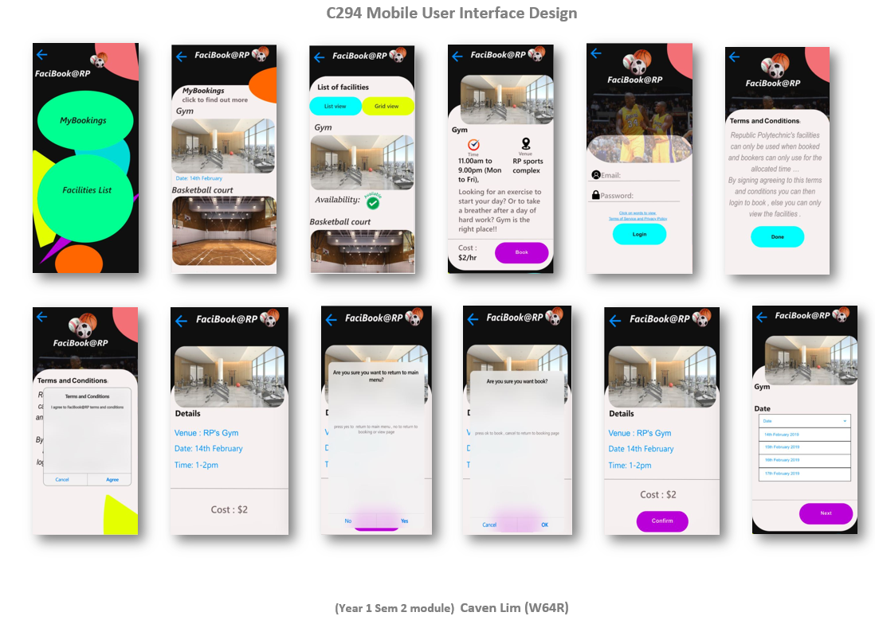

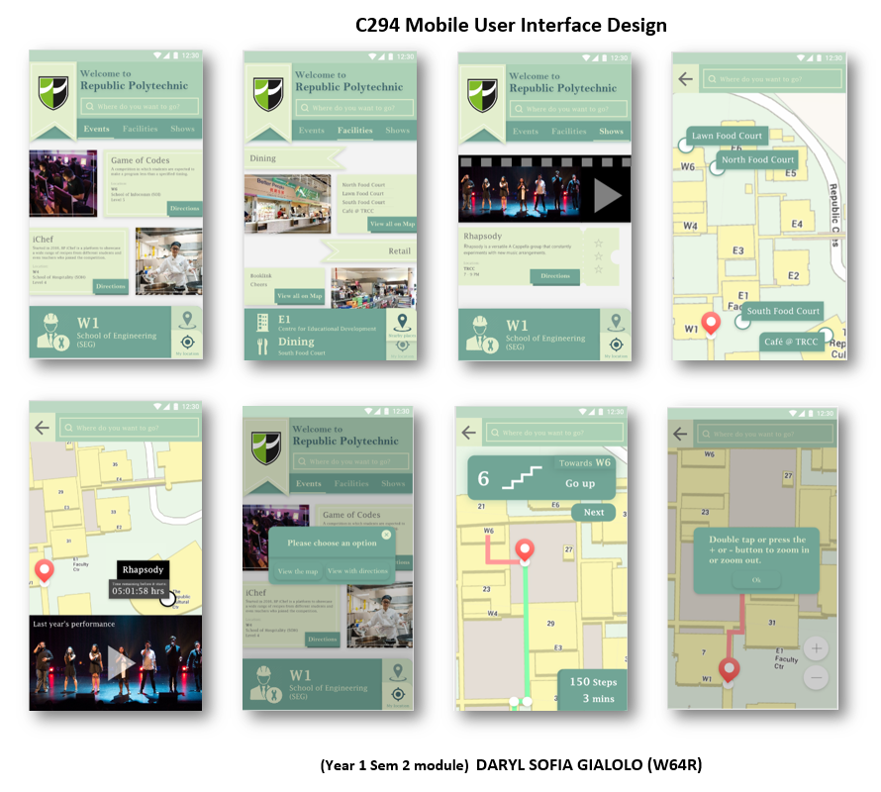

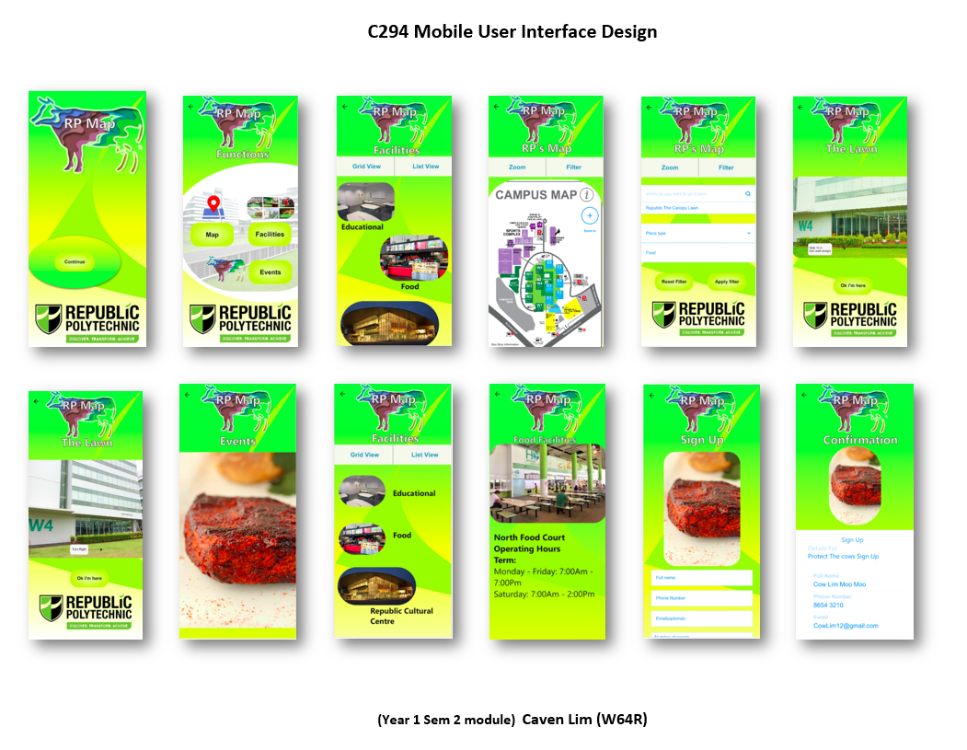

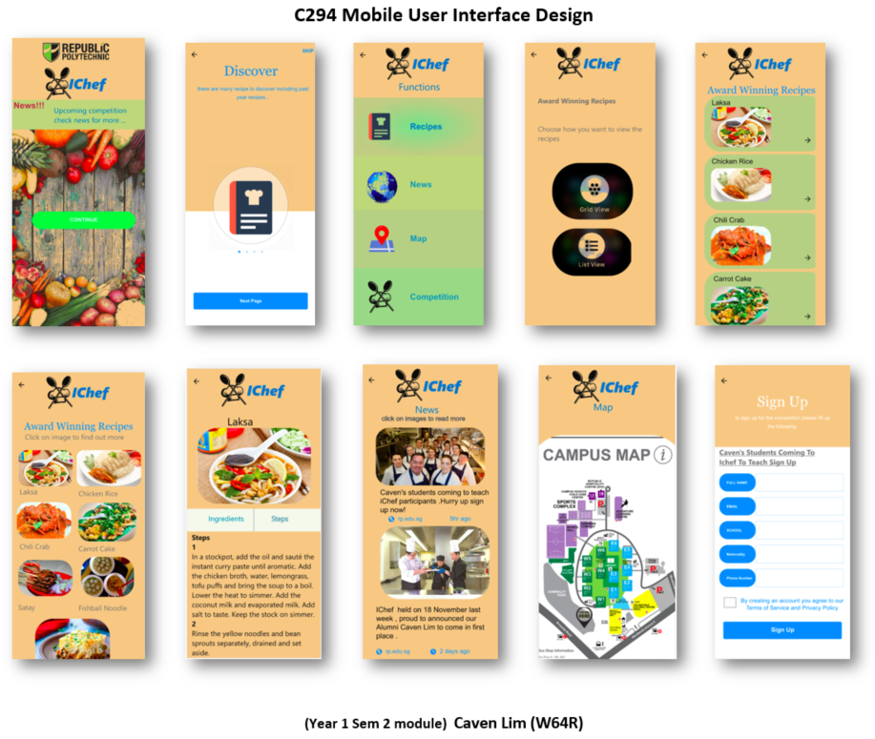

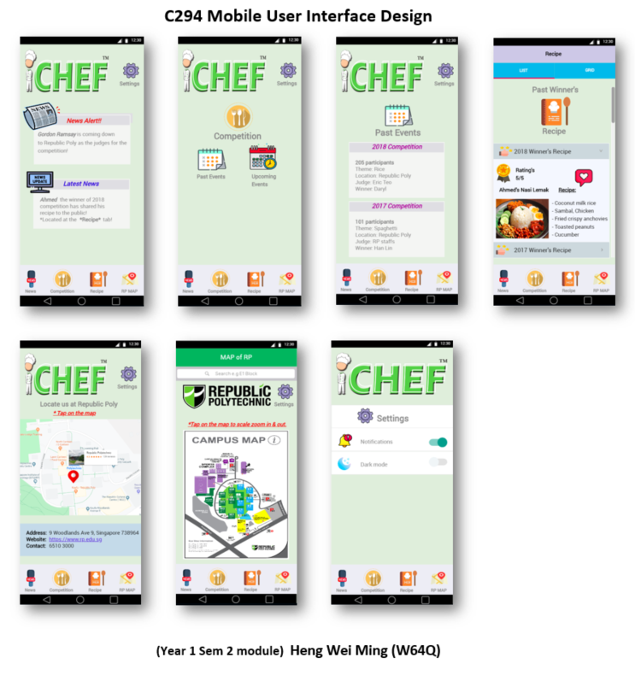

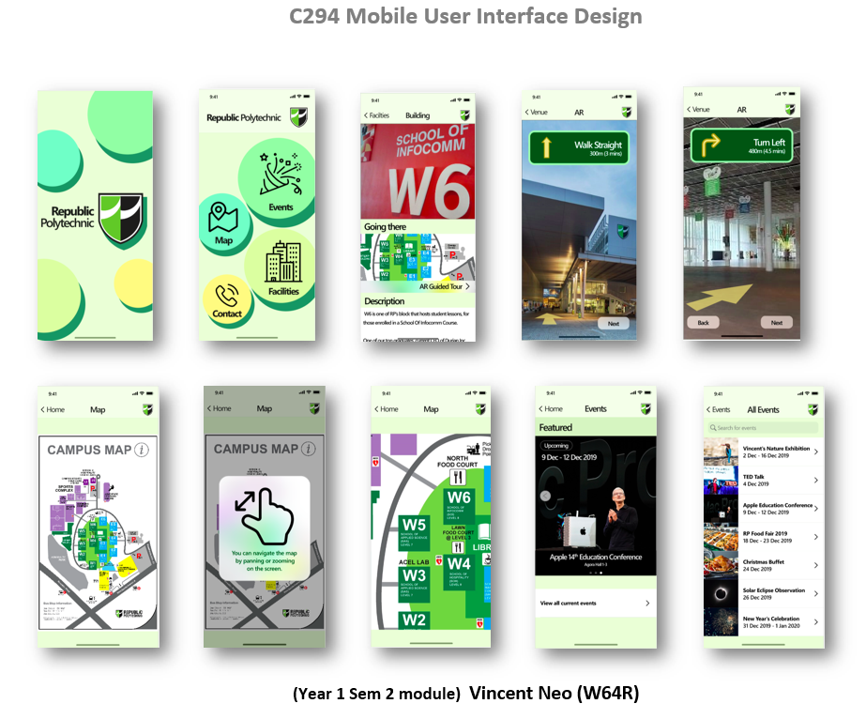

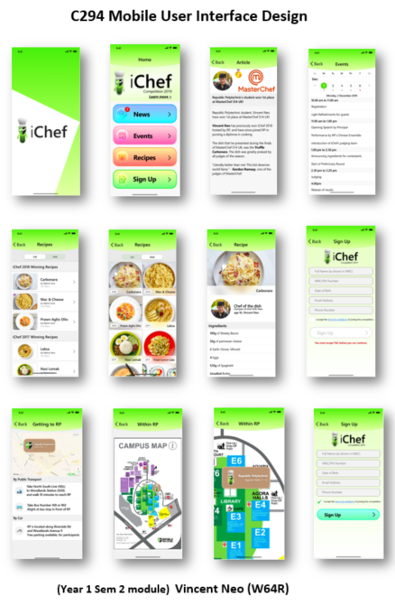

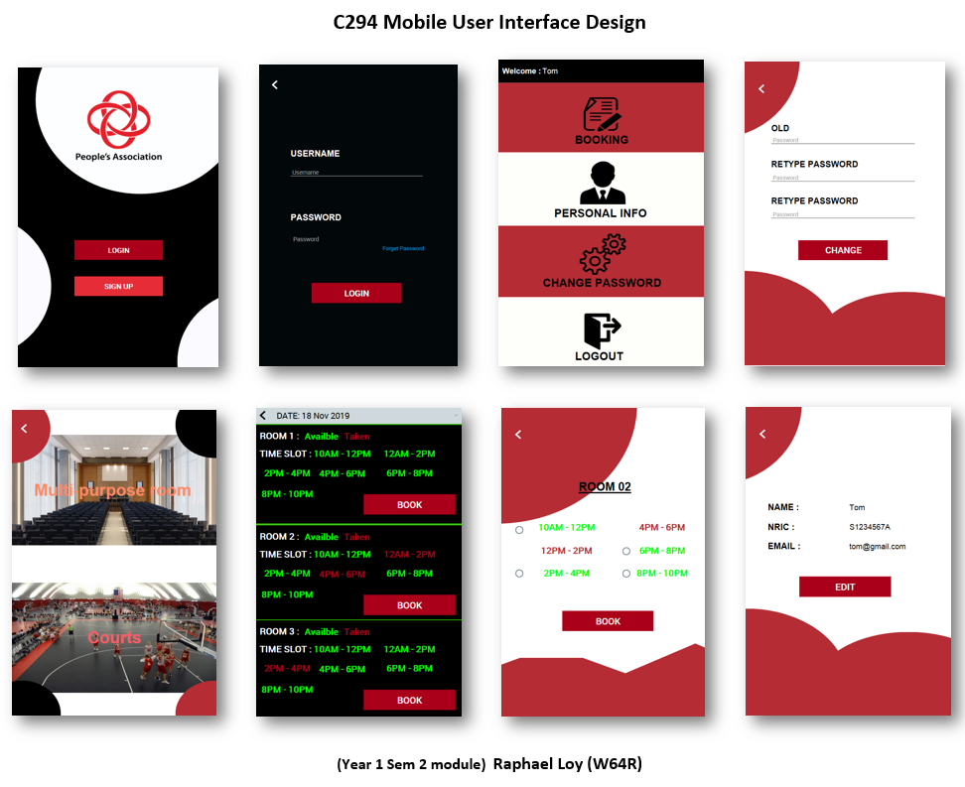

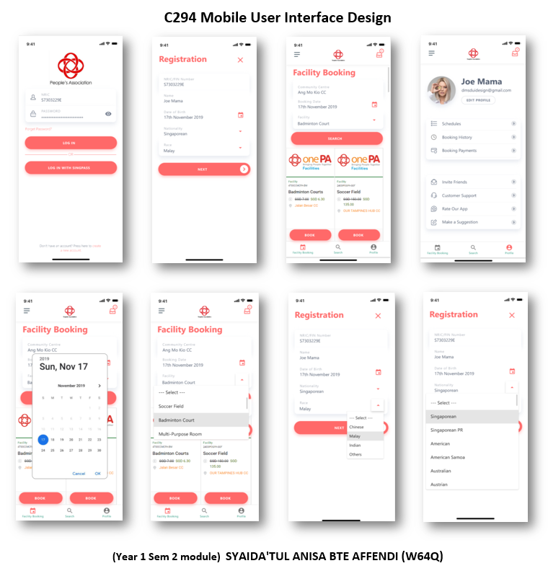

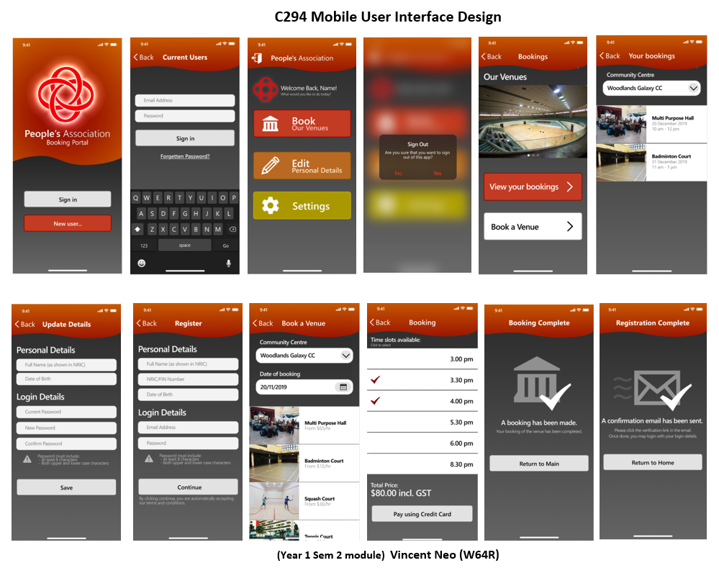

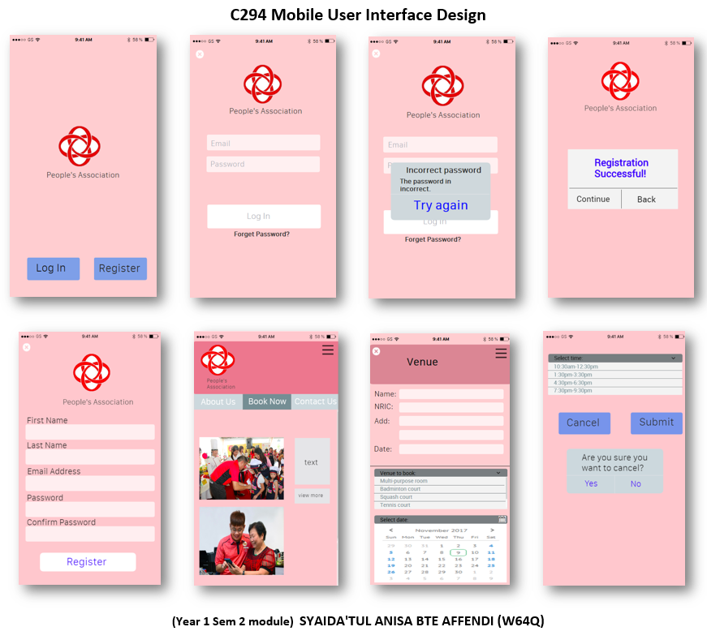

# Fellow DMSD Coursemate’s PD Blog

You may access the PD website of your coursemate using the following [link](https://bit.ly/c390dmsd).

These are examples of well designed blog site from your coursemate.

|  |  |  |
| --- | --- | --- |
| **No.** | **Name** | **Site** |
| 1 | CYAN GALVAN MEJICANO | <https://cynmjcn.wixsite.com/portfolio> |
| 2 |  |  |
|  |  |  |
|  |  |  |